Usage of GlycanBuilder2

- Run GlycanBuilder2
- Opening the software
  - macOS : click “run.command”.
  - Windows : click “GlycanBuilder2.jar”.
  - Linux : click “GlycanBuilder2.jar”.
- In order to run GlycanBuilder2, the 64-bit Java Runtime Environment (JRE) version 8.0 or later must be installed on the local computer.
- Operating system(s) - Platform independent.
The first screen of GlycanBuilder is the drawing canvas, as shown below. GlycanBuilder provides various icons above the canvas along the top. The function of these commands are described in section 2.

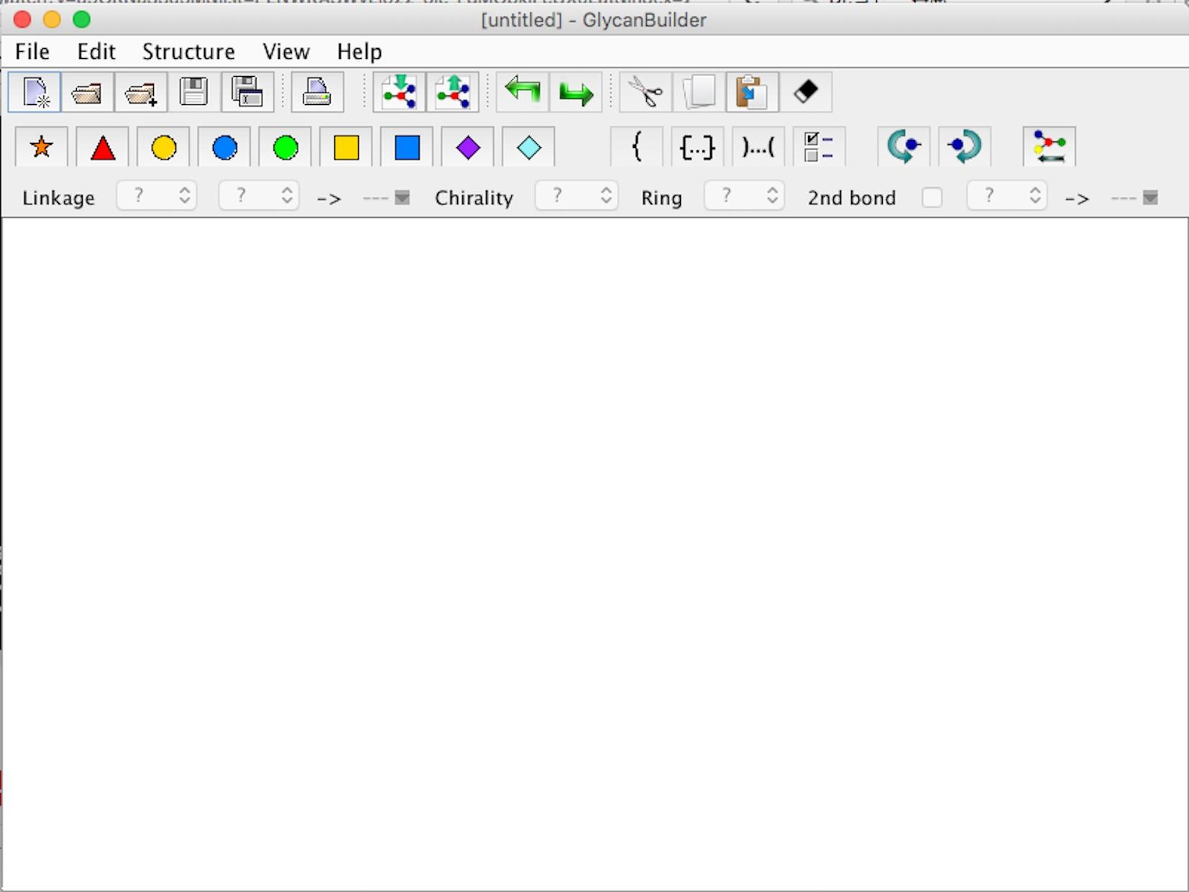
Figure 1. GlycanBuilder canvas.

- GlycanBuilder functions

  - The file menu
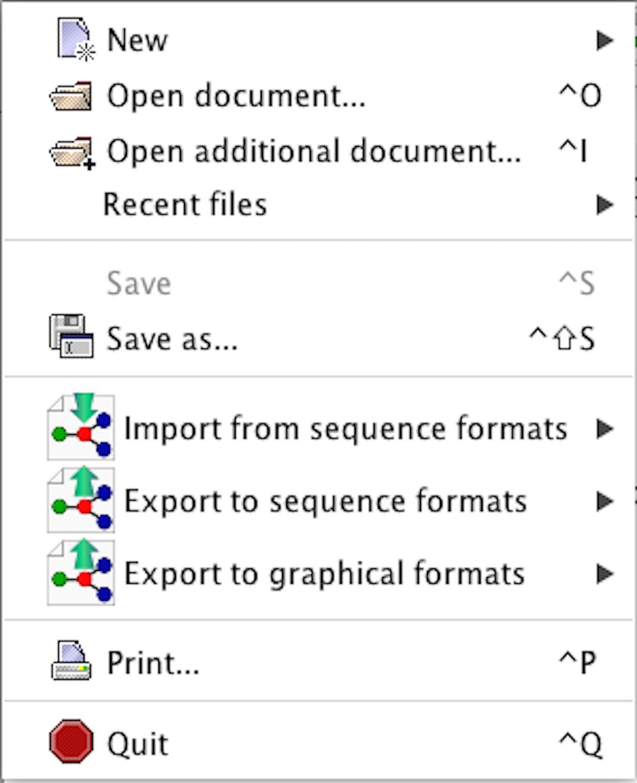
Figure 2. The file menu
- New : Clear the canvas and add a new structure on the canvas.
  - N-Glycans : Create a N-linked glycan core structure on the canvas.
  - O-Glycans : Create an O-linked glycan core 1-8 structure on the canvas.
  - Glycosphingolipids : Create a glycosphingolipid on the canvas.
  - GAG : Create a glycosaminoglycan on the canvas.
  - Milk sugars : Create a milk sugar on the canvas.

- Open document : Open a GlycoWorkbench structure file (.gws).
- Open additional document : Open another .gws file and add the glycan onto the canvas.
- Save : Save all glycan structures on the canvas into a GlycoWorkbench structure file (.gws).
- Save as : Save all glycan structures on canvas into a new GlycoWorkbench structure file (.gws).
- Import from sequence formats : Add glycan structure from one of the following sequence format files:
  - BCSDB (.bcsdb)
  - CabosML (.cabosml)
  - Carbbank (.carbbank)
  - GlycoMinds (.cfg)
  - GlycoBase (.glycobase)
  - GlycoCT{Condensed} (.glycoct_condensed)
  - GlycoCT{XML} (.glycoct_xml)
  - Glycominds (.glycominds)
  - GlycoSuite (.glycosuite)
  - Glyde II (.glyde)
  - Linucs (.gwlinucs)
  - IUPAC-Condensed (.iupac_condensed)
  - IUPAC short ver.1 (.iupac_short_v1)
  - IUPAC short ver.2 (.iupac_short_v2)
  - KCF (.kcf)
  - LINUCS (.linucs)
  - OGBI (.ogbi)
  - SimGlycan (.simglycan)
  - WURCS (.wurcs)

- Export to sequence formats : Store the selected glycans on the canvas into one of the following glycan sequence formats.
  - GlycoWorkbench sequence (.gws)
  - GlycoCT{Condensed} (.glycoce_condensed)
  - GlycoCT{XML} (.glycoct_xml)
  - Glycominds (.glycominds)
  - Glyde II (.glyde)
  - LINUCS (.linucs)
  - WURCS (.wurcs)

- Export to graphical formats : Output the glycan structures on the canvas into one of the following image file formats.
  - Bitmap (.bmp)
  - Encapsulated PostScript (.eps)
  - Joint Photographic Experts Group (.jpg)
  - Portable Document Format (.pdf)
  - Portable Network Graphics(.png)
  - Post Script (.ps)
  - Scalable Vector Graphics (.svg)

- Print : Print the canvas.
- Quit : Shut down GlycanBuilder.

  - The edit menu
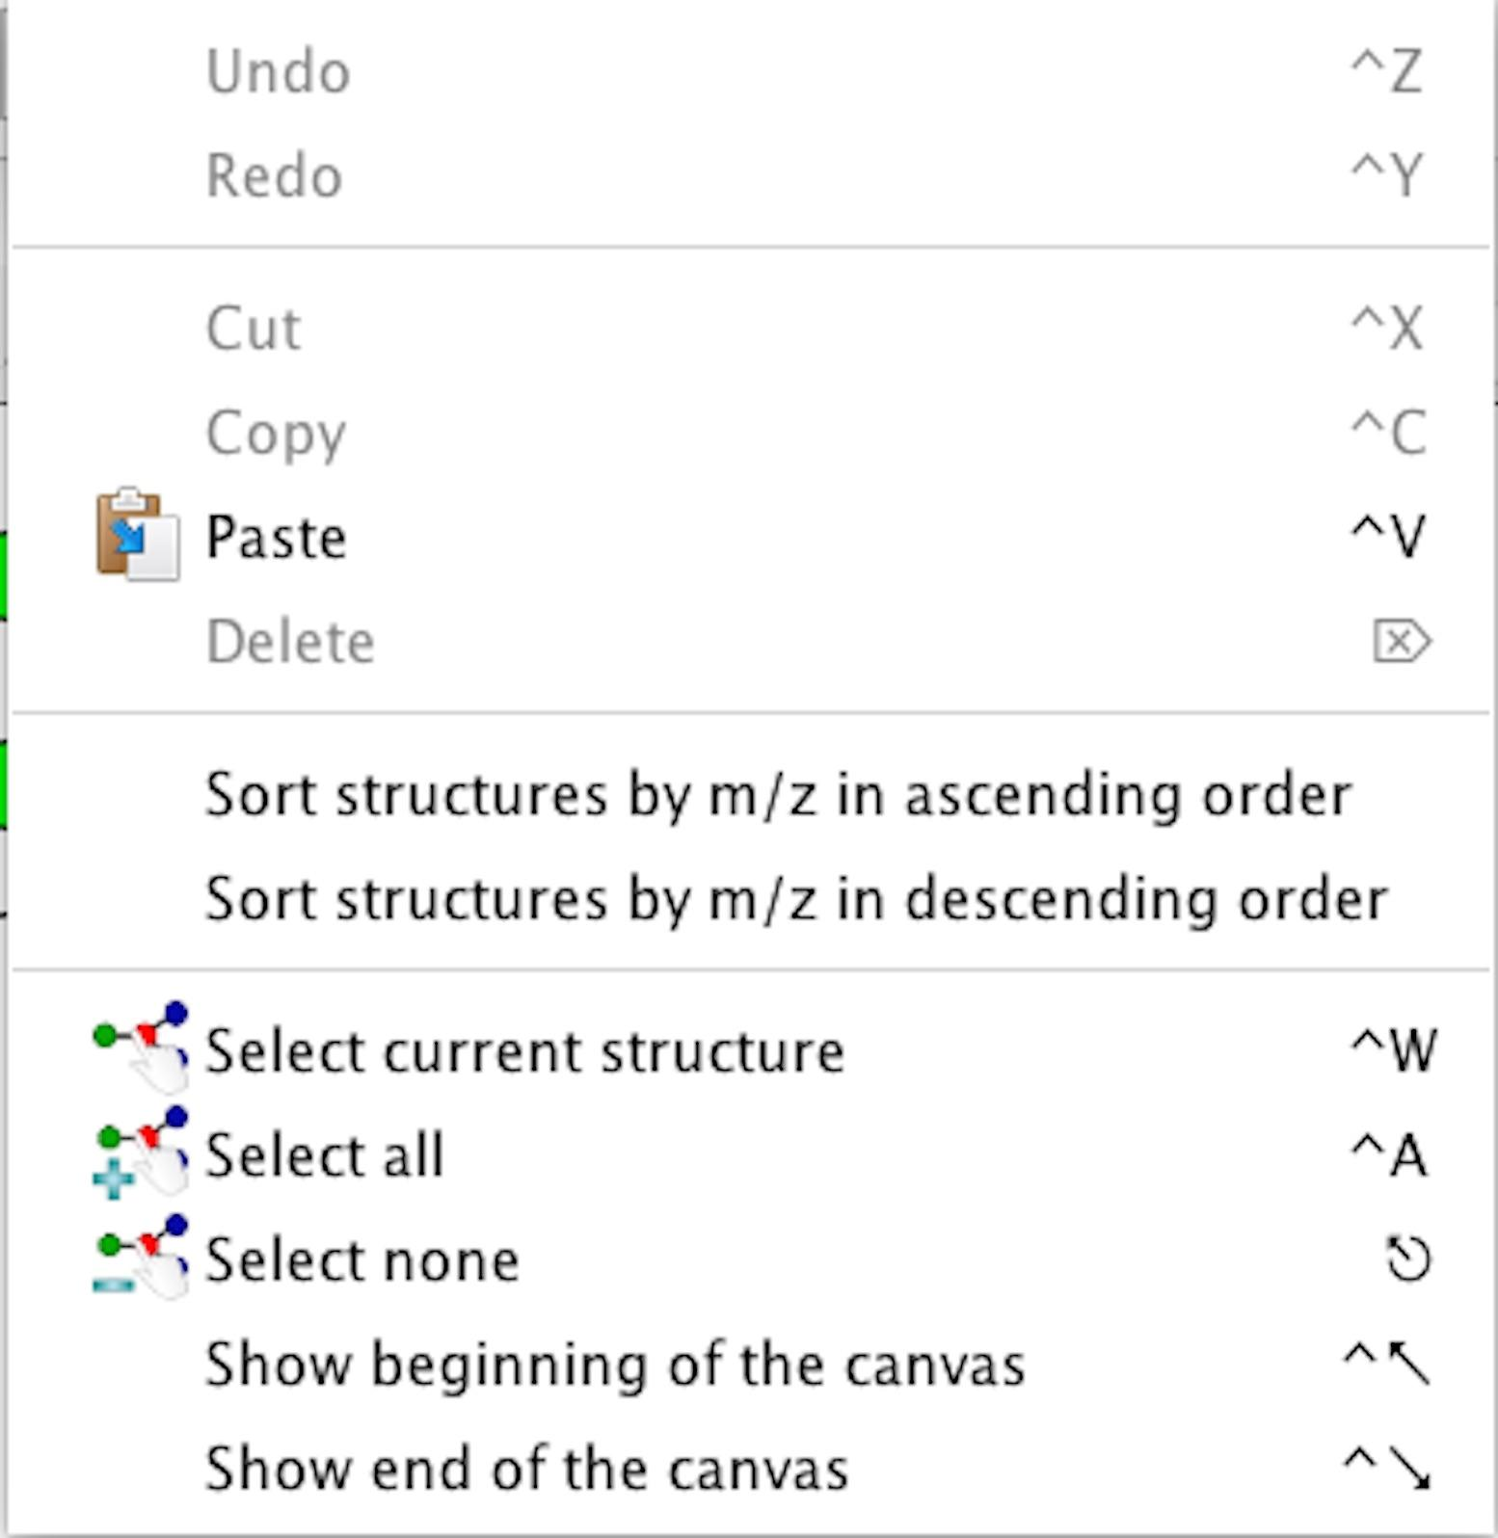
Figure 3. The edit menu
- Undo : Clear the previous action.
- Redo : Retry the previous action.
- Cut : Cut the selected residue or (sub)structures. Residue includes monosaccharide, substituent, or structural symbol.
- Copy : Copy the selected residue or glycan (sub)structures.
- Paste : Paste the cut or copied residue or glycan (sub)structures onto the canvas.
- Delete : Delete the selected residue or glycan (sub)structures.
- Sort structures by m/z in ascending order : Sort glycan structures on the canvas by m/z in ascending order.
- Sort structures by m/z in descending order : Sort glycan structures on the canvas by m/z in descending order.
- Select current structure : Select the whole structure from the currently selected residue.
- Select all : Select all glycans on the canvas.
- Select none : Clear select status.
- Show beginning of the canvas : Move to the top of the canvas.
- Show end of the canvas : Move to the bottom of the canvas.

  - The structure menu
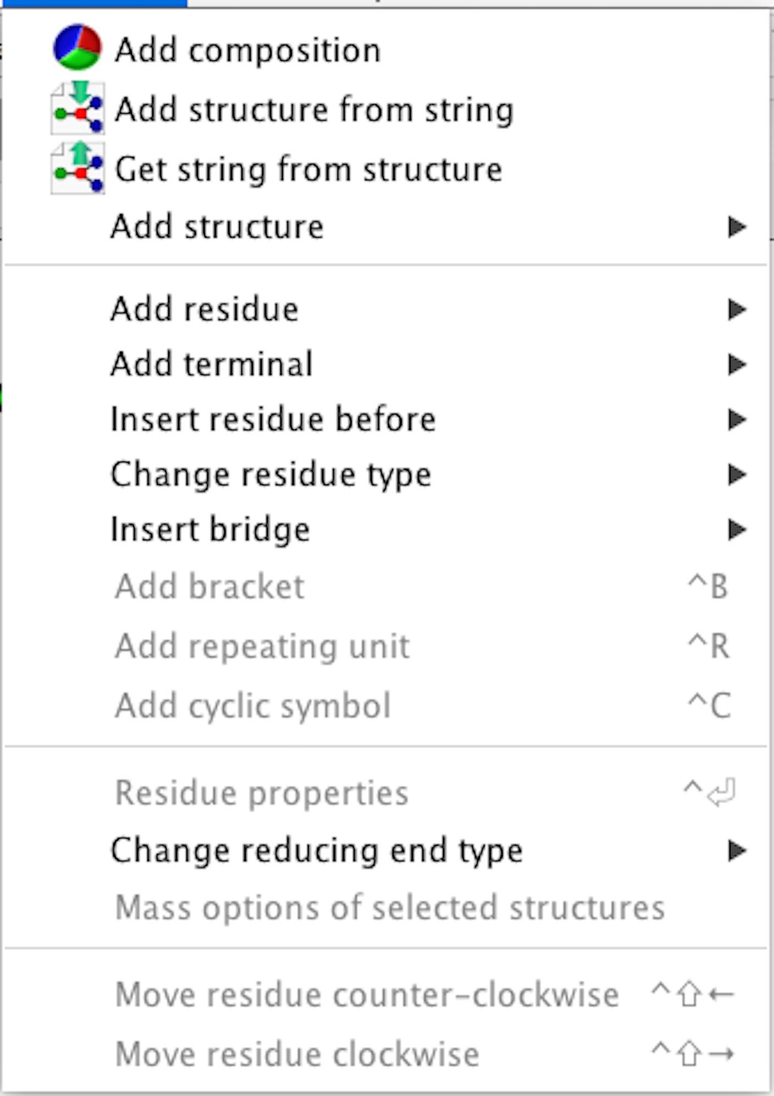
Figure 4. The structure menu
- Add composition : create monosaccharide composition
- Add structure from string : show import glycan sequence dialog on the canvas. Supported sequence formats are the same as the Import option under the File menu.
- Get string from structure : show export glycan sequence dialog on the canvas. Supported sequence formats are the same as the Export option under the File menu.
- Add structure : adds one of the following types of glycan substructures onto the canvas:
  - N-Glycans
  - O-Glycans
  - Glycosphingolipids
  - GAG
  - Milk sugars

- Add residue : Add a monosaccharide or substituent onto the canvas. If a residue is selected, the new residue to attached to it. This utility supports the following residues:
  - Ketose
  - Pentose
  - Hexose
  - Heptose
  - Hexosamine
  - Nonulosonate
  - Di-deoxy hexose
  - N-acetylated hexosamine
  - Hexo Ulosonic Acid
  - 6-deoxy hexose
  - 6-deoxy hexosamine
  - Unknown
  - Substituents
  - Modifications

- Add terminal : Add one of the following motif structures onto the canvas.
  - Antigen
  - Mannose
  - Lactosamine
  - Lewis motif

- Insert residue before : Insert a new residue to the currently selected residue. This utility supports the same residues as “Add residue”.
- Change residue type : Change the currently selected residue to another residue. This utility supports the same residues as “Add residue”.
- Insert bridge : Insert (or add) one of the following cross-linked substituent to the currently selected residue.
  - Amine : Insert substituent “N”.
  - Di-phosphoethanolamine : Insert substituent “PPEtn”.
  - N-Sulfate : Insert substituent “NS”.
  - Phosphoethanolamine : Insert substituent “PEtn”.
  - Phosphate : Insert substituent “P”.
  - Pyrophosphate : Insert substituent “PyrP”.
  - Pyruvate : Insert substituent “Py”.
  - (r)-pyruvate : Insert substituent “(R)Py”.
  - (s)-pyruvate : Insert substituent “(S)Py”.
  - Succinate : Insert substituent “Suc”.
  - Sulfate : Insert substituent “S”.
  - Triphosphate : Insert substituent “Tri-P”.

- Add bracket : Add a bracket for glycan fragments.
- Add repeating unit : Add repeating brackets around the selected residues.
- Add cyclic symbol : Add cyclic brackets to the currently selected residue.
- Residue properties : Assign various monosaccharide information to the selected residues. This utility supports the following parameters :
  - Linkage position : Assign a parent linkage position to the selected residue.
  - Anomeric state : Assign an anomeric state to the selected residue.
  - Anomeric carbon : Assign an anomeric carbon to the selected residue.
  - Chirality : Assign a configuration to the selected residue.
  - Ring size : Assign a ring size to the selected residue.
  - Second bond : Assign a secondary linkage to the selected residue.
    - Parent position : Assign secondary parent position.
    - Child position : Assign secondary child position.
  - Probability low : Assign a minimum probability to the linkage.
  - Probability high : Assign a maximum probability to the linkage.
  - Linkage type (parent or child)
    - h : This linkage is a result of a replacement of the hydrogen of an OH group.
    - d : This linkage is a result of a replacement of the oxygen of an OH group.
    - o : This linkage is a result of a replacement of a hydrogen group.
    - x : This is an unknown linkage type.
    - n : This linkage links to substituents, non-monosaccharide entities, repeat or statistical units.
    - s : This linkage is a result of removal of a prochiral H-atom, resulting in an S-configuration.
    - r : Same as “s”, but resulting in an R-configuration.
    - u : This is an unvalidated linkage type, used as default.

- Change reducing end type : Change reducing end of currently selected glycan. This utility supports the following modifications :
  - Free end
  - Alditol
  - 2-Aminopyridine
  - 2-Aminobenzamide
  - Anthranilic Acid
  - 2,6-Diaminopyridine
  - 4-Aminobenzamidine
  - 4-(N-[2,4-Diamino-6-pteridinylmethyl]amino)benzoic acid
  - 7-Amino-4-methylcoumarin
  - 6-Aminoquinoline
  - 2-Aminoacridone
  - 9-Fluorenylmethyl carbazate
  - Dansylhydrazine
  - Deoxygenation

- Mass options of selected structures : Set reducing end type, number of positive or negative ion for whole structures. The following negative and positive ions are supported :
  - H
  - Na
  - Na-H
  - Li
  - Li-H
  - K
  - K-H
  - Cl
  - Cl-H
  - H₂PO₄
  - H₂PO₄-H

- Move residue counter-clockwise : Move selected residue counter-clockwise.
- Move residue clockwise : Move selected residue clockwise.

  - The view menu
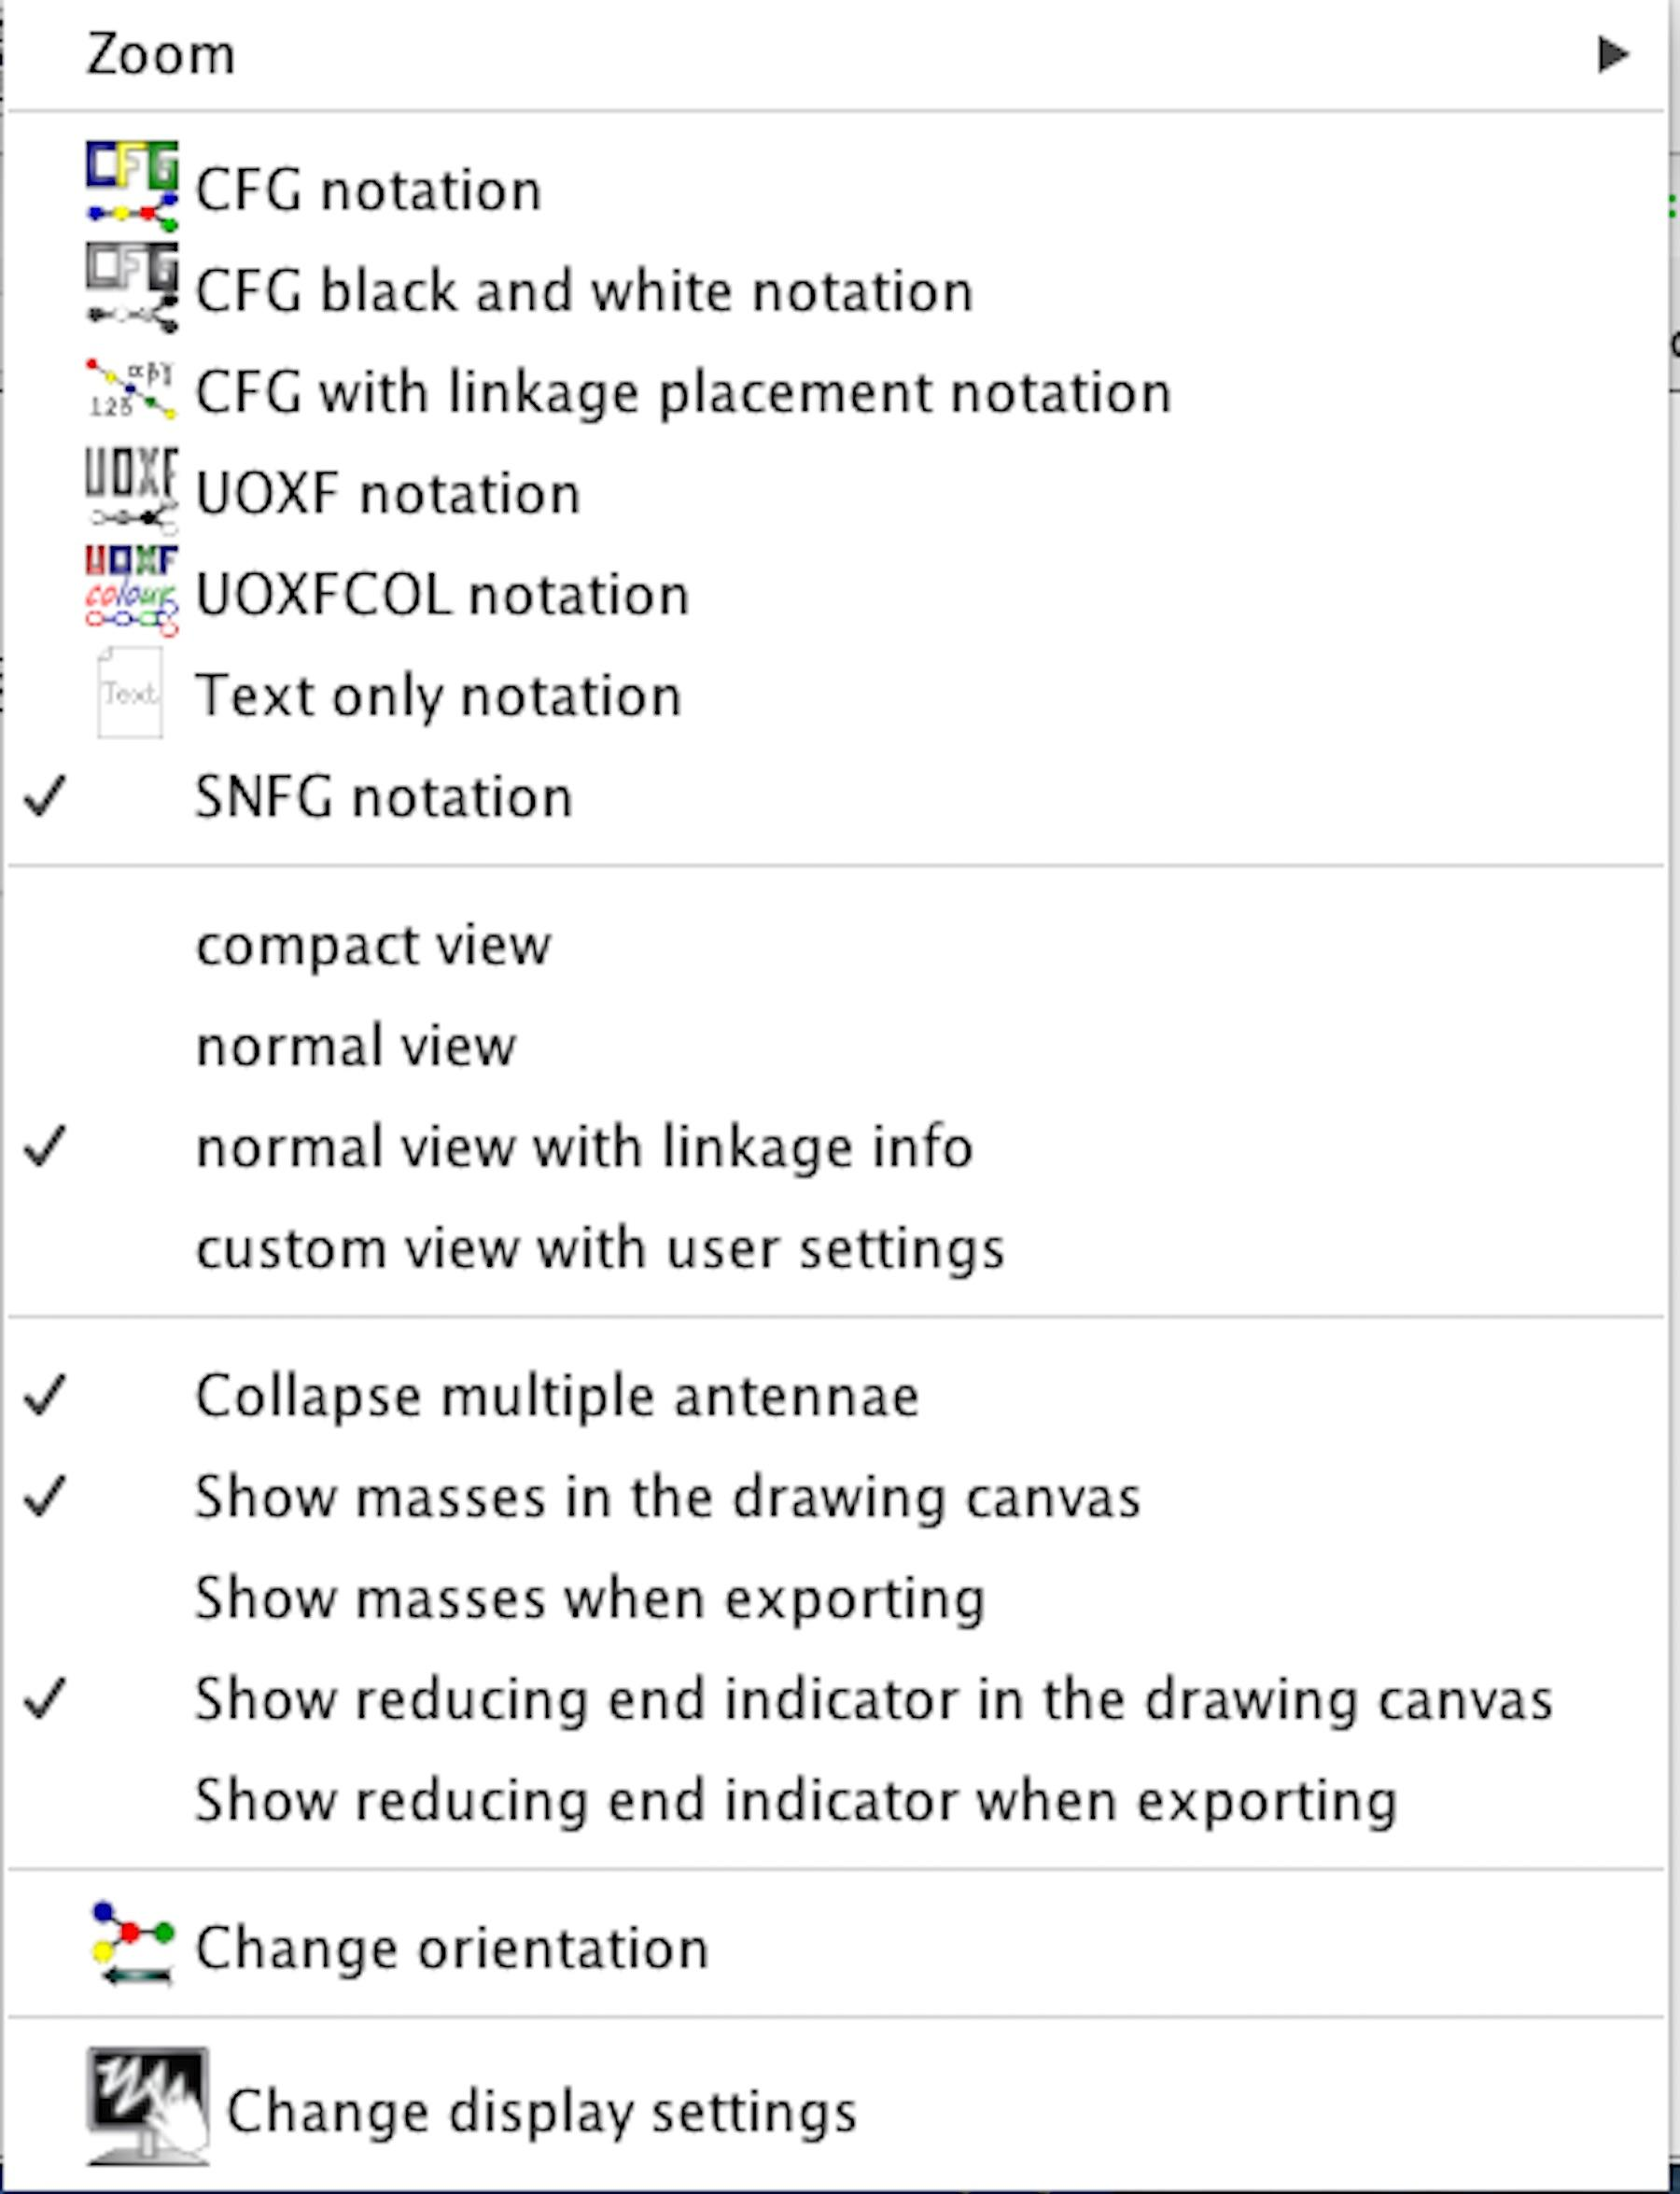
Figure 5. The view menu
- Zoom : Scale the canvas.
- CFG notation : Switch current symbol set to CFG notation.
- CFG black and white notation : Switch current symbol set to CFG gray scale.
- CFG with linkage placement notation : Switch current symbol set to UOXF like linkages with CFG symbols.
- UOXF notation : Switch current symbol set to UOXF notation.
- UOXFCOL notation : Switch current symbol set to UOXF color scaled.
- Text only notation : Switch current symbol set to IUPAC three letter code.
- SNFG notation : Switch current symbol set to SNFG notation.
- compact view : Hide linkage information. Linkage length is displayed shorter than in the normal view.
- normal view : Switch to standard linkage size without any linkage informations.
- normal view with linkage info : Switch to standard linkage size showing linkage information including anomeric symbol and anomeric carbon position.
- custom view with user setting : Linkage size, font style, and font size defined by user can be functionally assign to all glycan structures.
- Collapse multiple antennae : When building multiple fragments, toggle between displaying them separately or combining them.
- Show masses in drawing canvas : Show mass value for each glycan.
- Show masses when exporting : Output mass value for each glycan structure when exporting into any graphic file.
- Show reducing end indicator in drawing canvas : Display the reducing end symbol for each glycan structure.
- Show reducing end indicator when exporting : Output the symbol of the reducing end when exporting into any graphic file.
- Change orientation : Rotate the glycan structures on the canvas 90 degrees clockwise.
- Change display settings : Change the font style and font size used to display residue, linkage position and mass values. Note that this functionality can change the spacing between residues and linkages.

  - Toolbar buttons
Some of the menu options described above are provided as buttons on the toolbar, located above the canvas. Each command is assigned a unique icon, as described in Table 1.
Table 1. Name of commands on the canvas.
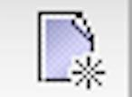  Reset | 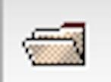  Open document | 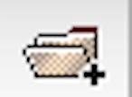  Open additional document |   Save document | 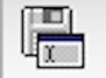  Save as | 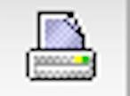  Print
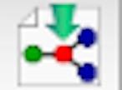  Import string | 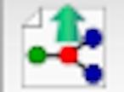  Export string |   Undo |   Redo |   Cut |   Paste
  Copy |   Delete |   Add Lyx | 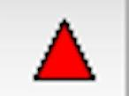  Add Fuc | 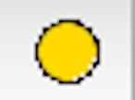  Add Gal | 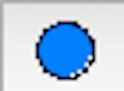  Add Glc
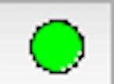  Add Man | 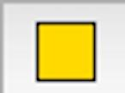  Add GalNAc | 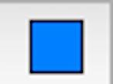  Add GlcNAc | 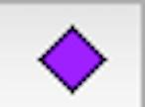  Add NeuAc | 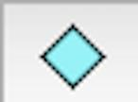  Add NeuGc | 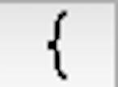  Add bracket
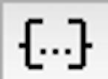  Add repeat | 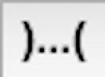  Add cyclic | 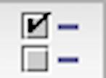  Residue properties |   Move residue counter-  clockwise | 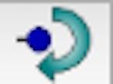  Move residue clockwise | 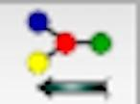  Orientation

  - Assign monosaccharide informations
Figure 6. Subtoolbar of GlycanBuilder.

GlycanBuilder provides a subtoolbar above the canvas as in Figure 6. This utility can be used to assign anomeric information, ring size and linkage information to the selected residue, which can also be selected using the "Residue properties" functionally (See section 3.1).

- Draw glycan structure

  - Add monosaccharide
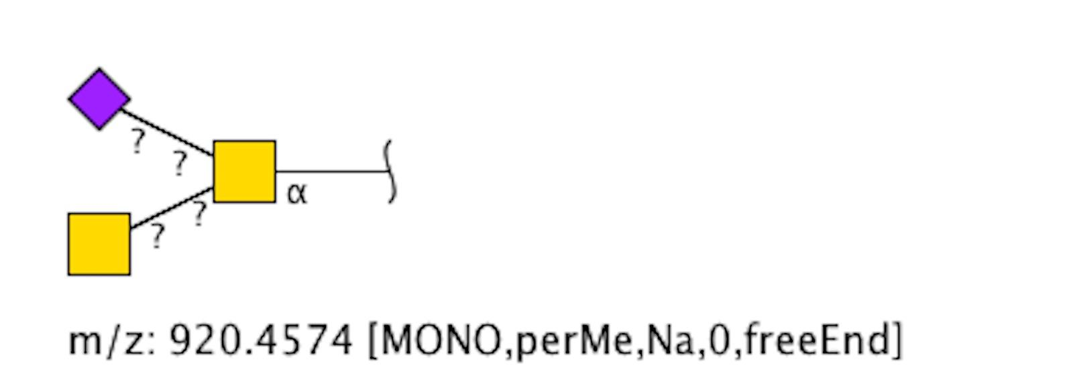 | The selected symbol is automatically draw on canvas when clicked (buttons in red box). When a new monosaccharide is added, it is automatically assigned as the reducing end. Subsequent monosaccharides are added to the selected monosaccharide (bold border) as they are clicked. Other monosaccharides not in this toolbar can be added using “Add residue”, “Insert residue before” or “Change residue type”.
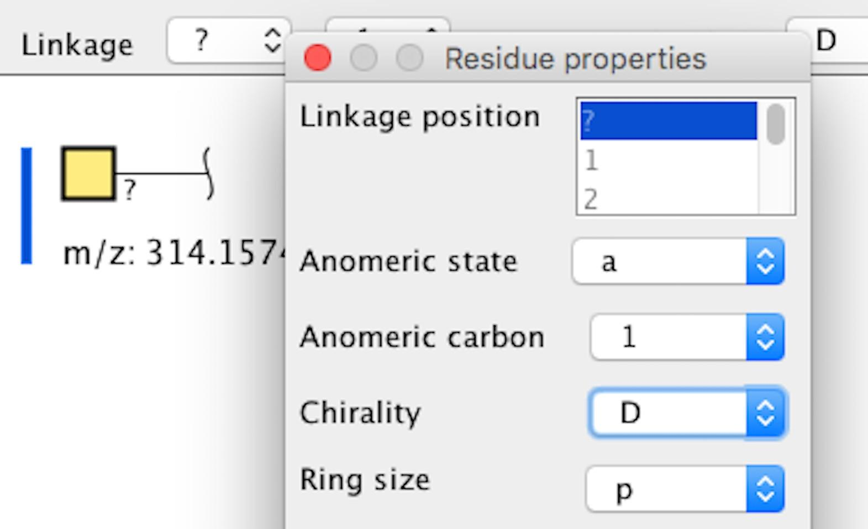  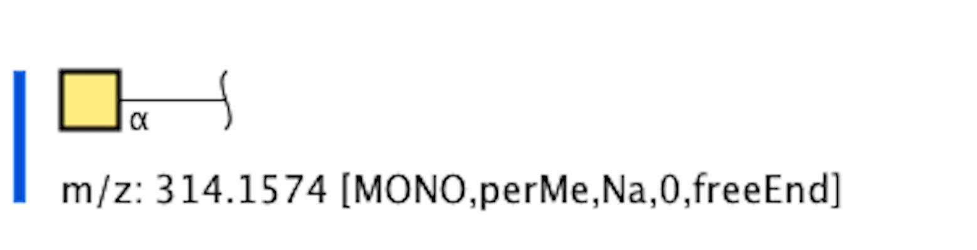 | Each monosaccharides can be assigned an anomeric state, anomeric carbon, D- or L-configuration (figure represented as “Chirality”) or ring size. For example, GlcNAc is specified as alpha-D-GlcpNAc when its anomeric state was changed to alpha from “?”.
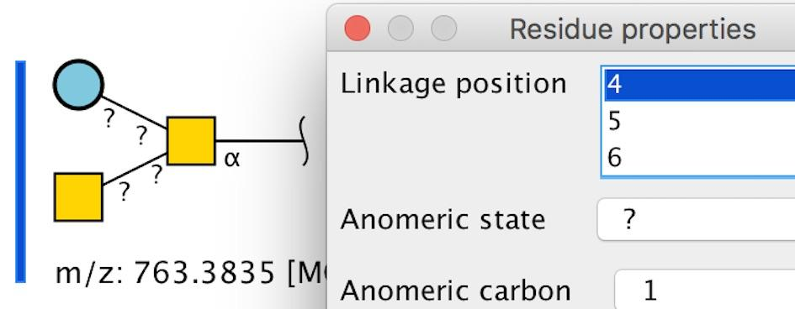  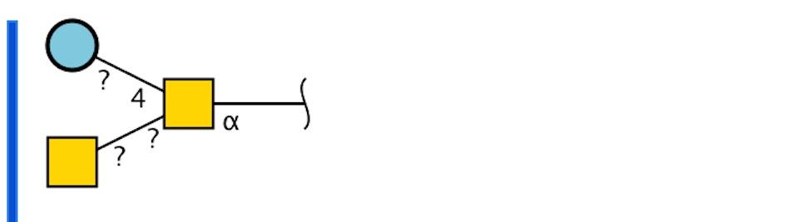 | Donor side linkage position can be assigned by selecting the monosaccharide and selecting Linkage position, which is indicated as “anomeric state + linkage position”. For example, ?-D-Glc linked to C4 of alpha-D-GalpNAc is represented as “? 4”. If these monosaccharides are ambiguously linked such as to either C4 or C5, this fuzzy linkage position can be represented as “? 4/5” by selecting multiple positions (using shift-key and clicking on multiple positions).

  - Add substituent
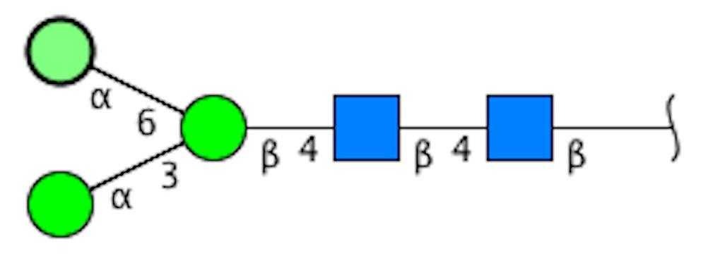 | Simple substituents can be added to the selected monosaccharide.
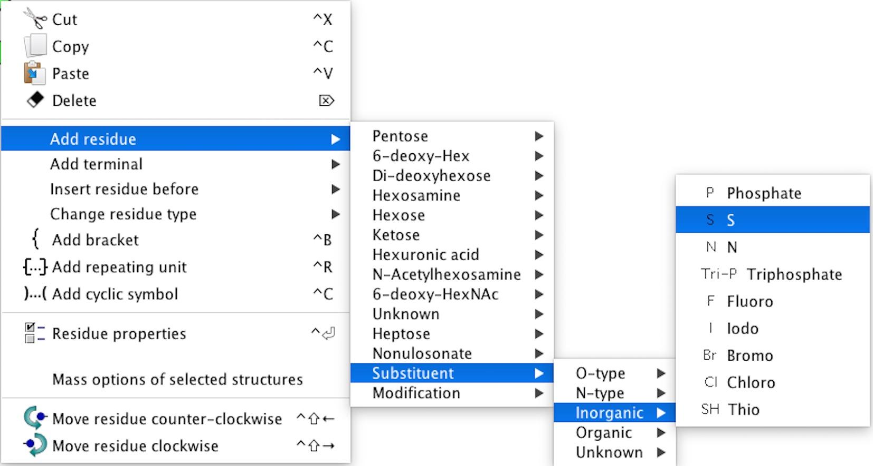
Substituent is listed under “Add residue” in the “Structure” menu. In this example, sulfate (S) is selected.
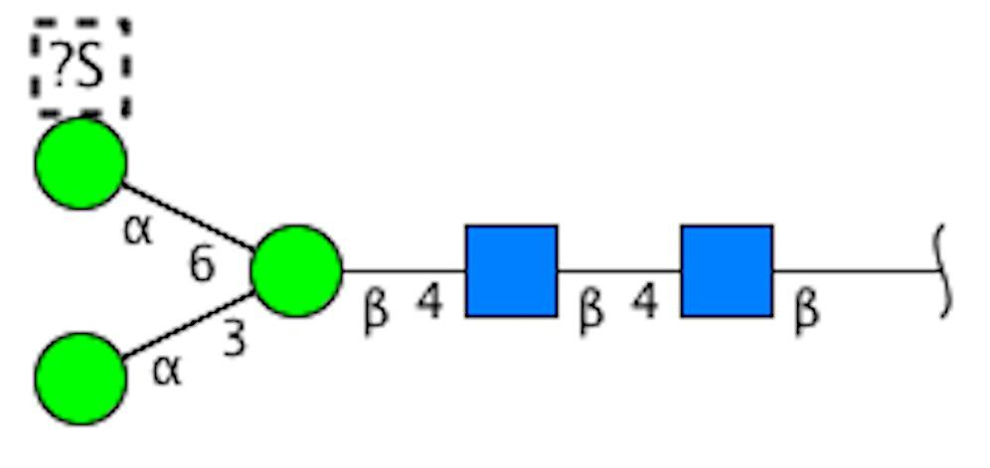 | Sulfate is added at the top of the selected residue. This substituent can be changed to other substituents by selecting “Change residue type”. Also, linkage position can be assigned by selecting“Residue properties”.

  - Draw glycan motif structure
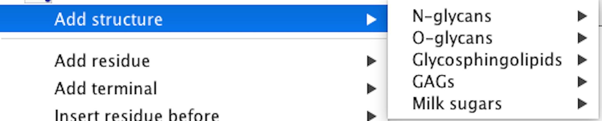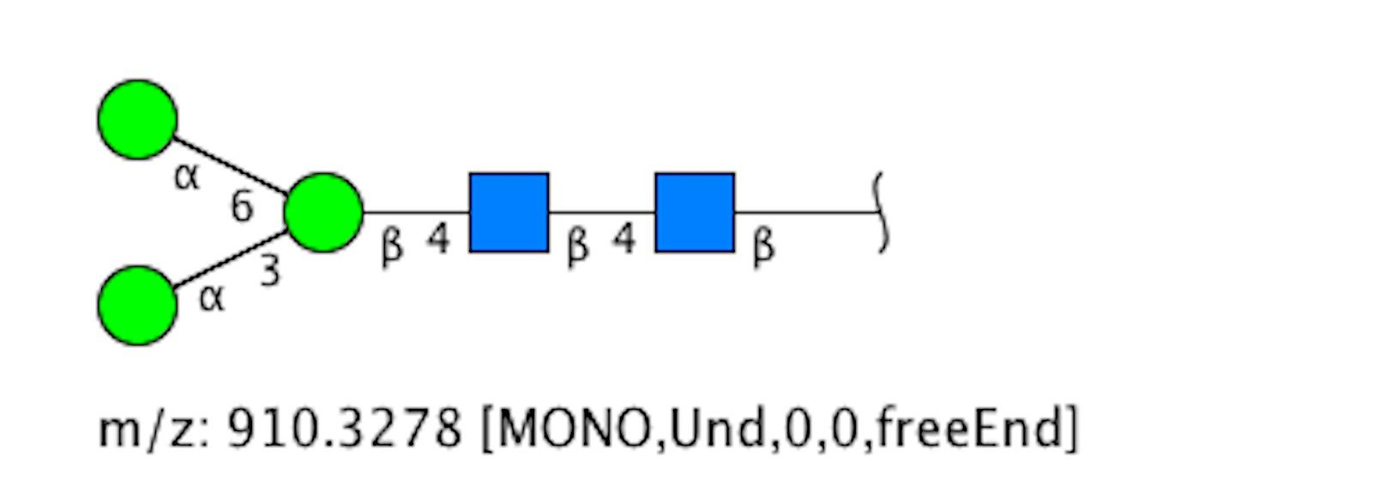
Any common glycan substructure can be drawn using “Add structure” under the structure menu. This example illustrates the N-linked glycan core structure.

  - Add repeating brackets
GlycanBuilder depicts repeating structures using brackets “[“ and “]” surrounding one or more monosaccharides. Repeating units can be assigned by using the "Add repeating unit" button.
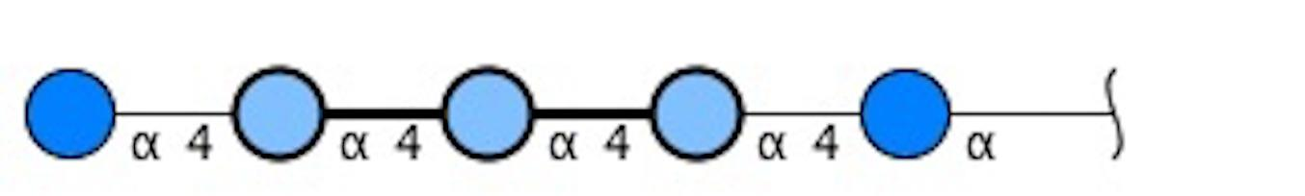 | Select one or more monosaccharides of the glycan structure on canvas. This example shows three monosaccharides selected in the center of the structure.
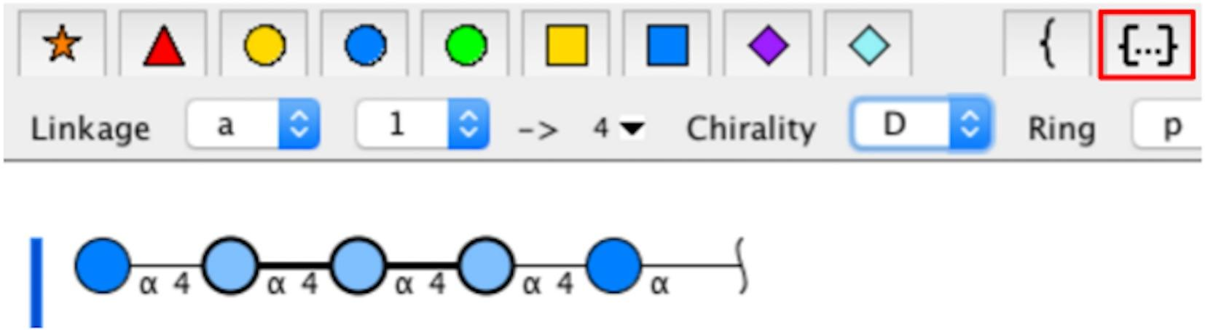 | Click the “Add repeating unit” button on the toolbar or the structure menu.
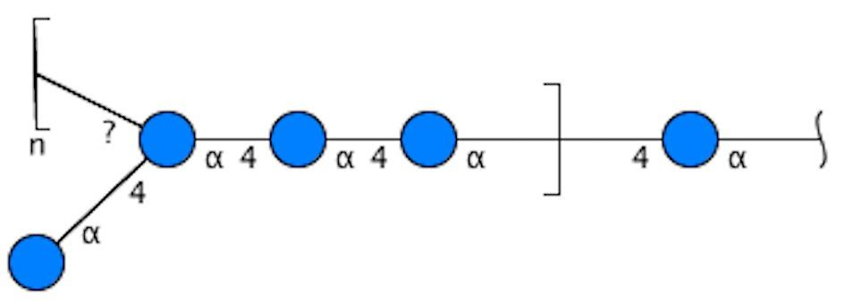 | A repeating block is inserted around the selected monosaccharides. “Add repeating unit” automatically defines the number of repeats as unknown. Thus, this repeating unit is annotated as “n”.
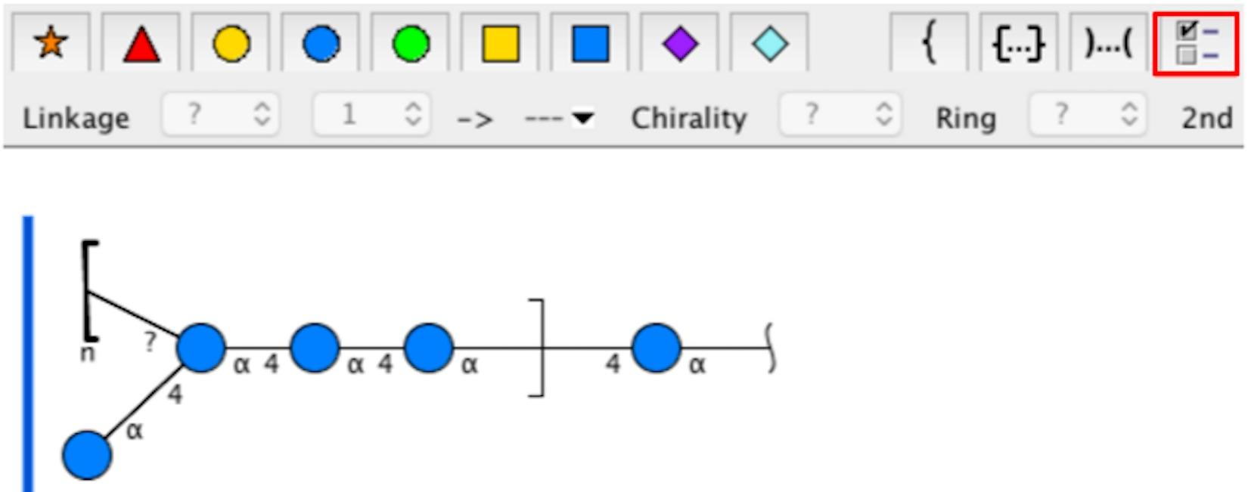 | The minimum and maximum range of repeats can be changed by selecting the end repeating bracket “[“ and clicking on the “Residue properties” button on the toolbar or under the “Structure” menu.
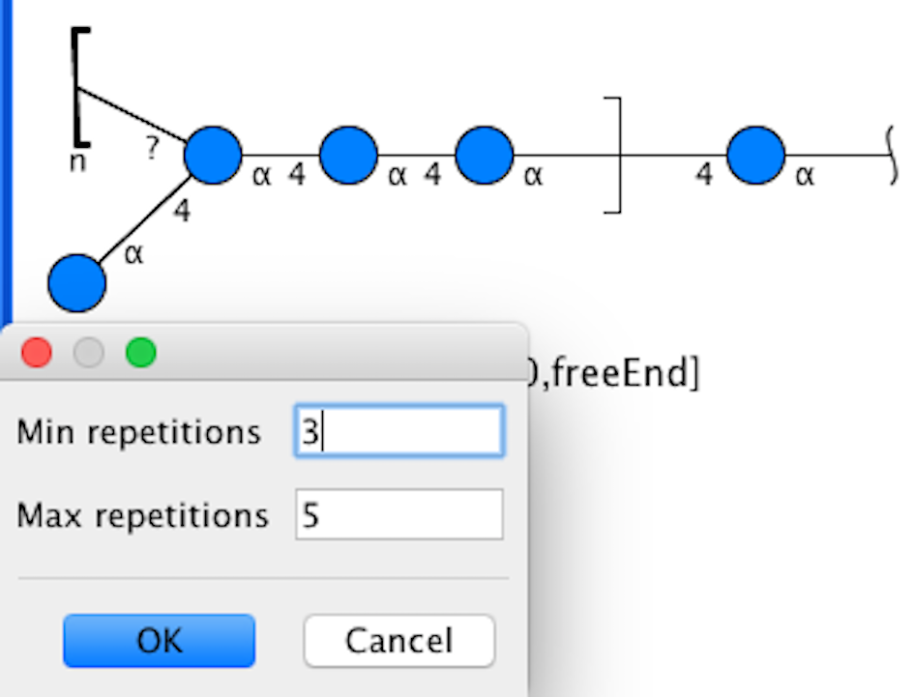 | The “Repetition count menu” will be displayed. Input values for min and/or max. This example set this range to 3 to 5. If either repeating count is unknown, its value should be set to -1.
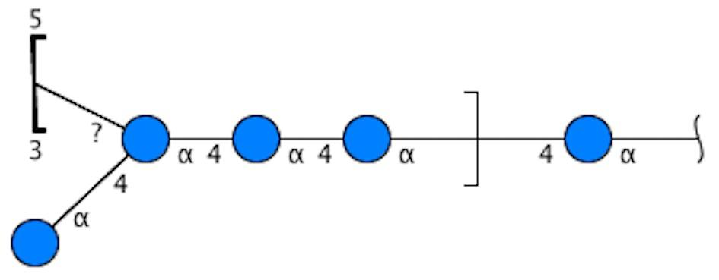 | The repeating count is depicted at the end repeating bracket.

  - Add a bracket of glycan fragments
GlycanBuilder supports the representation of glycan fragments. Glycan fragments are
separated from the core glycan structure by a curly bracket “{”.
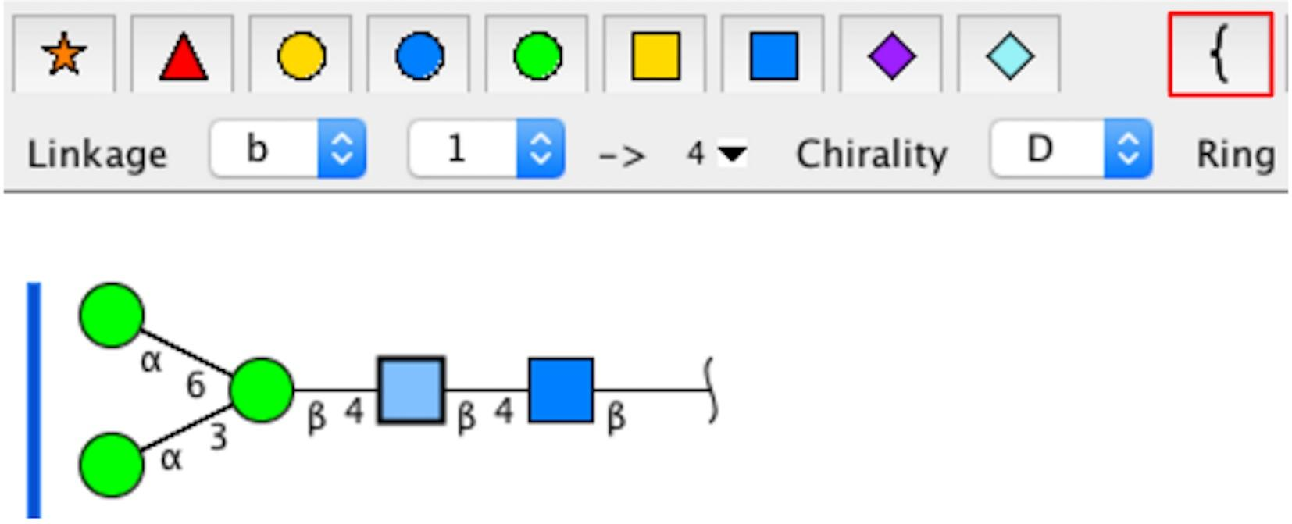 | Select any residues on the canvas and click on the “Add bracket” button (red box) on the toolbar or under the “Structure” menu,
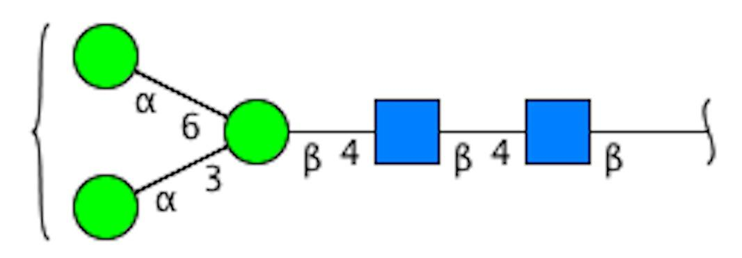 | A bracket is added at the non-reducing end of the glycan.
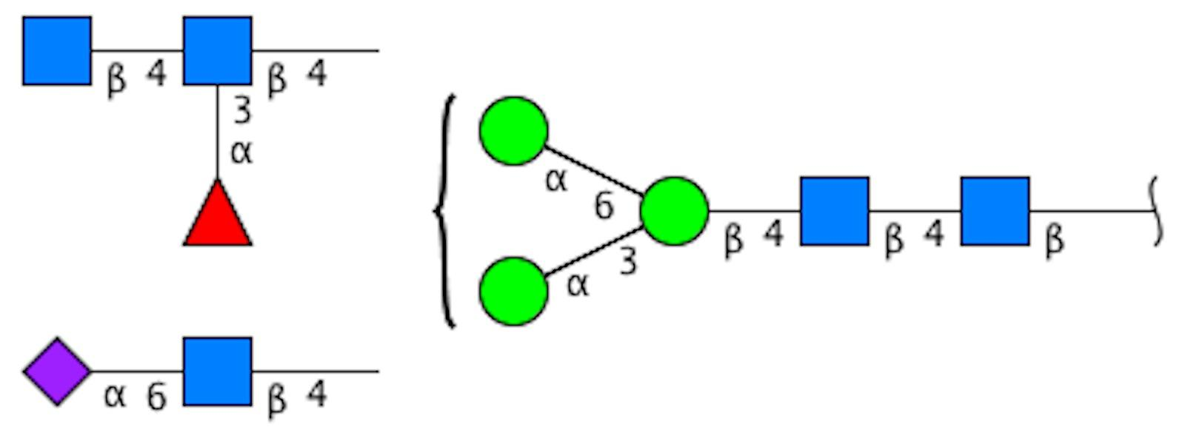 | Glycan subunits can be added by selecting the bracket and adding monosaccharides or substructures.

  - Change reducing end type
The reducing end of the glycan structure on the canvas can be specified.
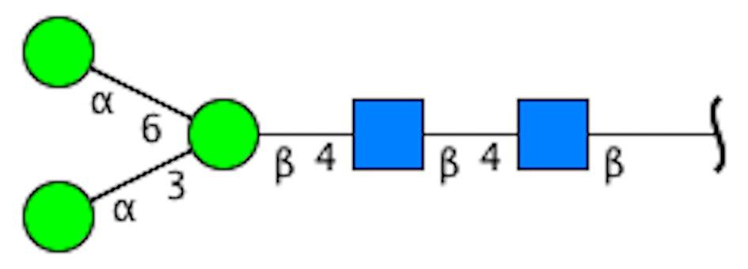 | Select the reducing end of the glycan structure.
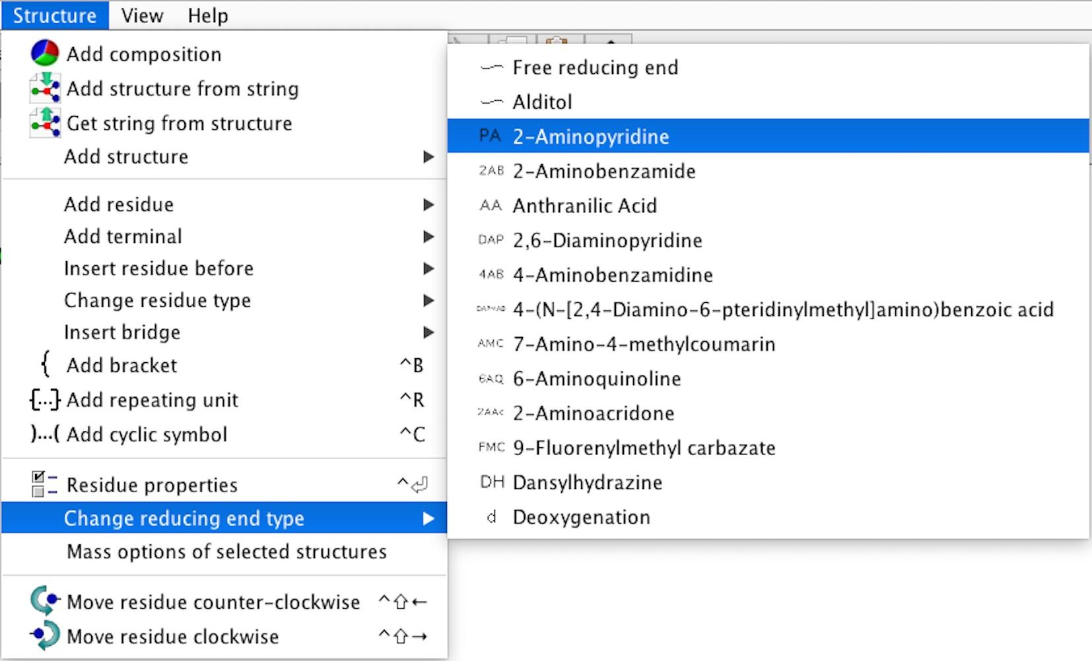
Select “Change reducing end type” under the “Structure” menu and select a type.
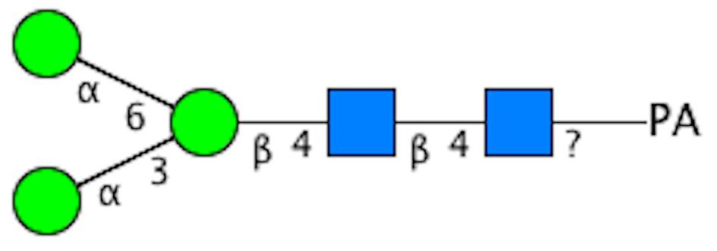 | The reducing end will be changed. In this example, it is set to 2-Aminopyridine(PA).

- Export glycan sequence format

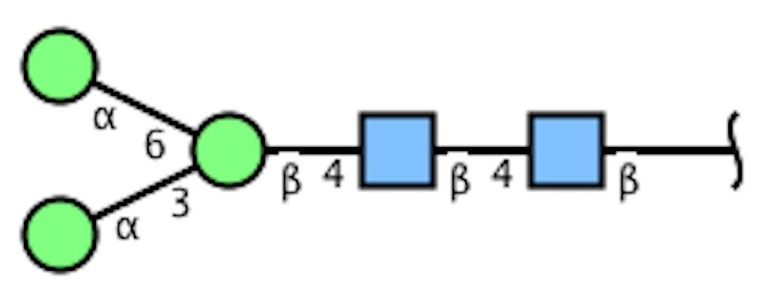 | Select the whole glycan.
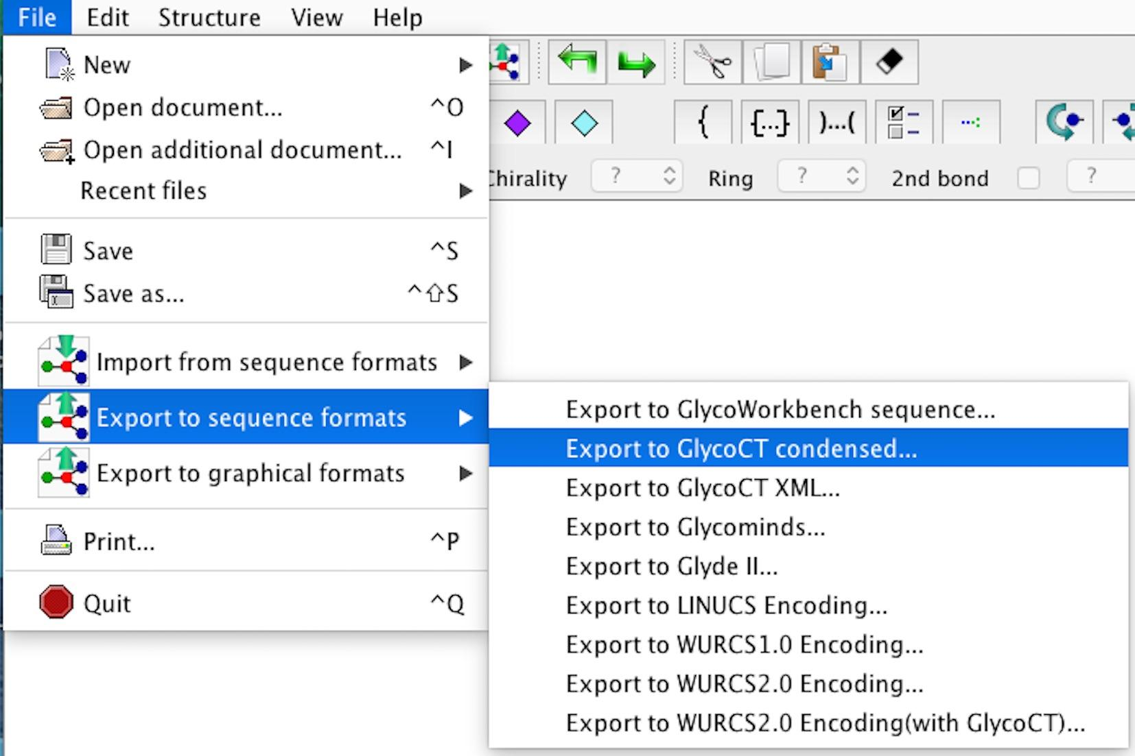 | Select sequence formats.  GlycanBuilder implements two types of "Export glycan sequence format". The export utility under the "File" menu outputs any glycan sequence format into a text file. For example, a glycan structure can be converted to GlycoCT_{{Condensed}} format, which is stored in a sequence file with extension ".glycoct_condensed".
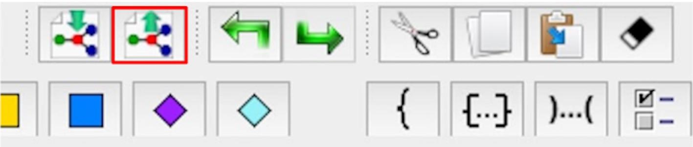 | Conversely, other “Export glycan sequence format” can be selected using the button in the red box. This option displays the glycan as text on the screen so that it can be copied.
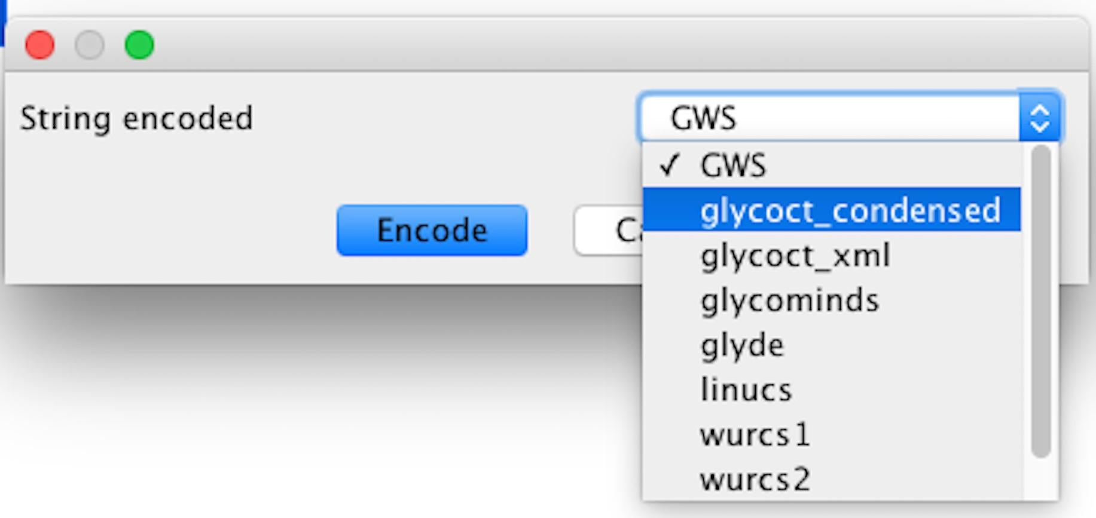 | From the export sequence menu, select an output format.
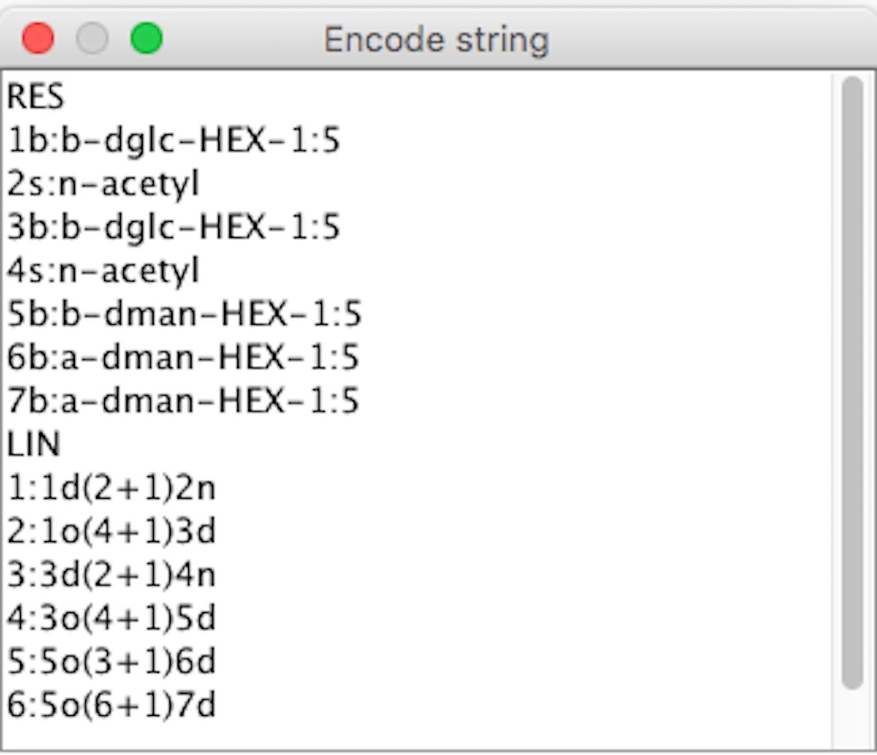 | A window is displayed with the glycan sequence text format.

- Import glycan sequence format
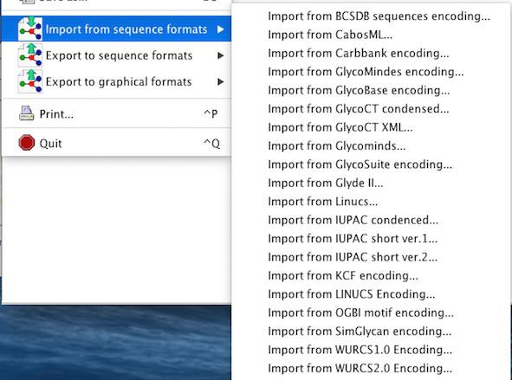 | GlycanBuilder provides two types of “Import from sequence formats”. The import utility under the “File” menu can read a file from any of the supported glycan sequence formats. For example, “Import from GlycoCT{Condensed} encoding” can read a sequence file containing a glycan in GlycoCT{Condensed} format, having file extension ".glycoct_condensed".
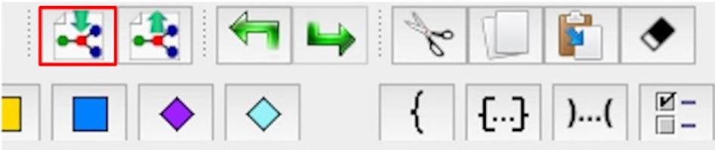 | Other “Import from sequence formats” can be used by selecting the button on the toolbar marked in the red box.
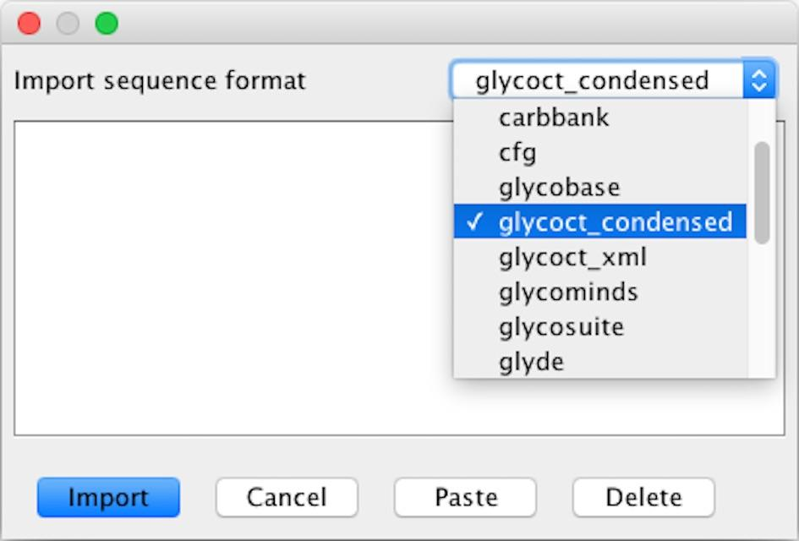 | A dialog box is displayed, from which the import sequence menu can be selected.
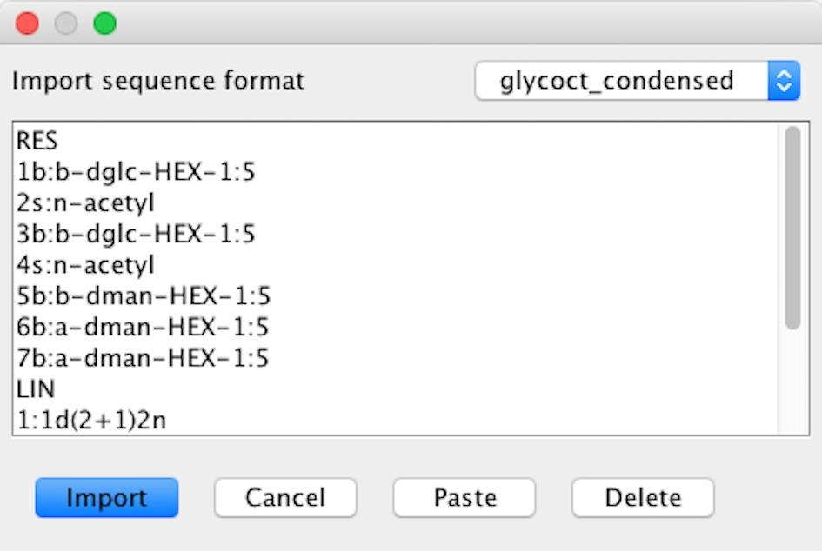 | Input the sequence in the format selected.
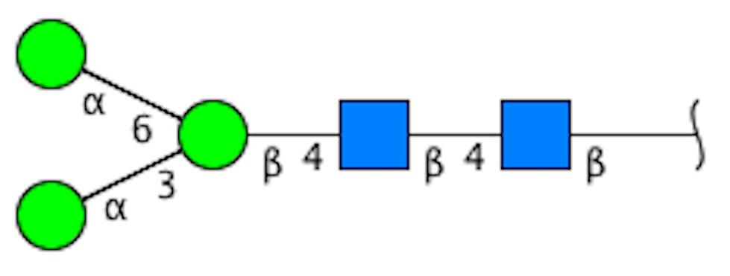 | Click the import button, and the glycan structure will be displayed on the canvas.

- Appendix
The source code of GlycanBuilder2 can also be freely obtained from GitHub (https://github.com/glycoinfo/GlycanBuilder2).

